MODULE 03

PASSIVE VOICE
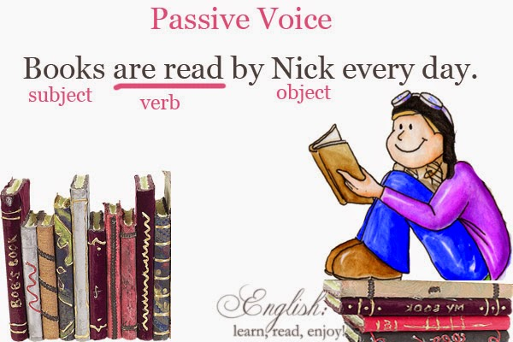

The Passive Voice

Present Tense

Simple Present Tense
The structure of the simple present tense is:
Active voice | Subject | + do/ does | + verb 1 | + object+ rest of the sentence.
Active voice | Father | Does | read | a newspaper.
Passive voice | Object | am/ is/ are | + verb 3(Past Participle) | +subject.
Passive voice | A newspaper | is | read | by father.

Active voice: They eat rice and curry for breakfast.
Passive voice: Rice and curry is eaten by them for breakfast

Passive form | Object | + am/ is/ are | + verb 3 | +subject | + rest of the sentence
Negative Form | Object | + am/ is/ are | +not + verb 3 | +subject | + rest of the sentence
Question Form | Am/ is/ are | +object | + verb 3 | +subject | + rest of the sentence?
- Active voice: The father reads a newspaper.

Passive voice: A newspaper is read by the father.
- Active (Negative): The father doesn’t read a newspaper.

Passive (Negative): A newspaper is not read by the father.
- Active (Question): Does the father read a newspaper?

Passive (Question): Is a newspaper read by the father?

Exercises:
Put the following sentences into passive voice. (Simple Present passive)
- Your father gives you pocket money.
- Do you clean your teeth every day?
- I donot learn English and French.
- The doctor drives a car.
- Kamala plays the piano well.
- Does the servant wash the floor everyday?

Present Continuous Tense

Passive voice

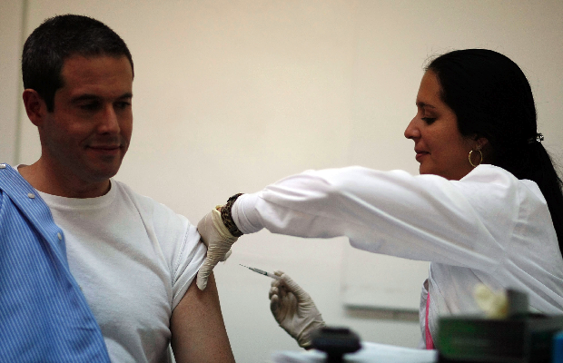

The lesson is being taught

by the teacher.

The drug is being injected

by the doctor.

The structure of the present continuous tense is:
Active voice | Subject | + am/ is/ are | + verb 1+ ing | + object+ rest of the sentence.
Active voice | Father | Is | reading | a newspaper.
Passive voice | Object | am/ is/ are+being | + verb 3(Past Participle) | Subject.
Passive voice | A newspaper | is being | read | by father.
Passive Form | Object + | am/ is/ are + |  | being + | verb 3 + (subject).
 | The mail | Is |  | being + | sent ( by Kumara)
Negative Form | Object + | am/ is/ are + | not + | being + | Verb 3 + (subject).
 | The mail | Is | not + | being + | Sent +( by Kumara)
Something is being done by someone at the moment.
Active: Kumara is sending the mail.
Passive: The mail is being sent by Kumara.
- Active: She is reading a novel.
Passive: A novel is being read by her.
- Active (negative): She isn’t reading a book.
Passive (negative): A book is not (isn’t) being read by her.
- Active (question): Is she reading a book?
Passive (question): Is a book being read by her.
Passive (negative question): Is not (Isn’t) a book being read by her.

When the verb is followed by a preposition
Active: My father is talking to a stranger.
(Here the noun a stranger is the object of the preposition to, and not the verb talking.)
Passive: A stranger is being talked to by my father.

Active: I am waiting for her.
Passive: She is being waited for by me.

Changing an interrogative sentence into a passive construction.
- Rule 1: When the active sentence begins with a question word such as when, whose, why, which and how, the passive sentence will also begin with a question word.
Active: why is he not reciting his poems?
Passive: Why are his poems not being recited by him?

- Rule 2: When the active sentence begins with who or whose, the passive sentence will begin with by whom or by whose.
Active: Whose sister is helping you?
Passive: By whose sister are you being helped?

- Rule 3: When the active sentence begins with whom, the passive sentence will begin with who.

Active: Whom are you waiting for?
Passive: Who is being waited for by you?

Exercises
Put the following sentences into passive voice. (Present continuous passive)

1. The cat is tearing the new book.
2. Is the agent chasing the criminal?
3. We are collecting the donations at the moment
4. They are washing my car now.
8. Medical researchers are recommending clinical guidelines for patients.
9. Are the masons building a house?
12. Whose teacher is helping you?
13. Why aren’t they signing the register?

Present Perfect Tense
The structure of the present perfect tense is:

Active voice | Subject | + has/ have | + verb 3(Past Participle) | + object.
 | Mother | Has | Cooked | Rice.
Passive voice | Object | has/ have + been | + verb 3(Past Participle) | Subject.
 | Rice | Has been | cooked | By mother.

Active voice: The shop keeper has opened his shop.
Passive voice: His shop has been opened by the shop keeper.

Passive form | Object | + has/have +been |  | + verb 3 | +subject | + rest of the sentence
Negative Form | Object | + has/have | + not +been | + verb 3 | +subject | + rest of the sentence
Question Form | Has/Have | +object |  | been+ verb 3 | +subject | + rest of the sentence?

- Active voice: Mary has bought a frock.
Passive voice: A frock has been bought by Mary.

- Active (Negative): Mary has not bought a frock.
Passive (Negative): A frock has not been bought by Mary.

- Active (Question) : Has Mary bought a frock?
Passive (Question): Has a frock been bought by Mary?

Exercises
Complete the following sentences using passive voice. (Present perfect passive)

- These magazines …………………..(buy) by me a week ago, but I haven’t paid for them.

- The bananas ……………………. (steal) by the monkey.
- My book …………………..(tear) by somebody.
- ……….the copies …………....(make) to distribute among students?
- A cake …………………..(make) by Nimali.
- The hall ………………….(not decorate) .
- …………the bill ……………(pay)?
- All the old papers ………………..(damage).
- The letters ………………………(deliver) by the post man.
- The victim ……………………(identify) as Kumara, a father of two sons.

Speaking (Role Play)

A family problem (Freeze Frame Drama)
A group plans three unmoving scenes (make a freeze) from three different stages of a family drama that highlights some problem in it.
After the first freeze, the groups discuss what has happened before that to make them act this way (according to what they understand from what they see).
After the last freeze, the group should come up with a story to justify the movements and a solution to the family problem. The class can select together what the best solution is.

Reading Comprehension

Pre-reading Activity
- What do you think are the most important discoveries made in the world?
- Why are they important? How did they change the world? Who discovered them?
- If you had a choice of making any new discovery, what will it be? Why?

The Discovery of Pencillin
The discovery of penicillin, one of the world’s first antibiotics, marks a true turning point in human history — when doctors finally had a tool that could completely cure their patients of deadly infectious diseases
Penicillin was discovered in London in September of 1928. As the story goes, Dr. Alexander Fleming, the bacteriologist on duty at St. Mary’s Hospital, returned from a summer vacation in Scotland and found that his lab had been left uncleaned and messy. But he found something else too.
Upon examining his Petri dishes which contained some colonies of Staphylococcus aureus, Dr. Fleming noted that they had been contaminated by a mold called Penicillium notatum. After carefully placing the dishes under his microscope, he was amazed to find that the normal growth of the staphylococci had been prevented by the mold.
It took Fleming a few more weeks to be sure – the mold was grown in enough quantity, outcomes were checked again to enable him to confirm his findings.
His conclusions turned out to be phenomenal: there was some factor in the Penicillium mold that not only inhibited the growth of the bacteria but, more important, might be harnessed to combat infectious diseases.
As Dr. Fleming famously wrote about that red-letter date: “When I woke up just after dawn on September 28, 1928, I certainly didn’t plan to revolutionize all medicine by discovering the world’s first antibiotic, or bacteria killer. But I guess that was exactly what I did.”
Fourteen years later, in March 1942, Anne Miller was treated with pencillin, becoming the first civilian patient to be successfully treated with it. She had been considered beyond saving, lying near death at New Haven Hospital in Connecticut, after miscarrying and developing an infection that led to blood poisoning.
But there is much more to this historic sequence of events.
Actually, Fleming’s laboratory at St. Mary’s was not equipped with the resources, nor was Fleming equipped with the necessary chemistry background to take the next giant steps of isolating the active ingredient of the penicillium mold juice, purifying it, figuring out which germs it was effective against, and how to use it.
That task fell to Dr. Howard Florey, a professor of pathology who was director of the Sir William Dunn School of Pathology at Oxford University. This landmark work began in 1938 when Fleming’s paper on the penicillium mold in The British Journal of Experimental Pathology was discovered by Florey, who had long been interested in the ways that bacteria and mold naturally kill each other. Florey had been leafing through some old journals when he came across this article. Soon after, Florey and his colleagues assembled in his well-stocked laboratory and the journey to discover one of the greatest findings of medical sciences was begun.
Many lives were being lost due to infection when this discovery was made. This was the time of World War II, and more soldiers were being killed by infections than by actual fighting, as no medicine had been discovered by then to stop wounds turning septic. Fleming’s discovery lead to the production of pencillin – but the creation of the mass drug was the work of a group of key scientists, who worked tirelessly on problems that had seemed unsurmountable at that time.
(Based on the article at http://www.pbs.org/newshour/rundown/the-real-story-behind-the-worlds-first-antibiotic/)
Comprehension
- Why is the discovery of Pencillin important?
- Is the discovery of Pencillin accidental? Why do you say so?
- Who is Dr. Howard Florey?
- Why couldn’t Fleming continue the work of developing the drug in his own lab? Give two reasons.
- Who was the first patient treated with Pencillin?

We use simple past tense to talk about an action happened in past.

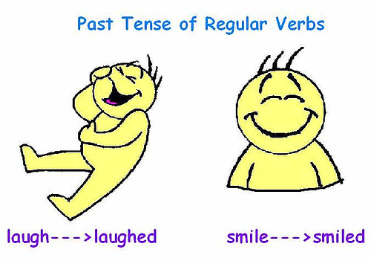

The structure of simple past tense is:

Active voice | Subject | + verb 2(Past tense) | +object + (rest of the sentence).
 | Nirmal | repaired | the car
Passive voice | Object | +was/ were+verb3 | + subject
 | The car | was repaired | by Nimal

Passive Form | Object | +was/ were+verb3 |  | +subject | + rest of the sentence
Negative Form | Object | +was/ were+ | not +verb3 | +subject | + rest of the sentence
Question Form | Was /were | +Object | + verb 3 | + rest of the sentence

- Active voice: He posted the letter immediately.
Passive voice: The letter was posted by him immediately.

- Active (Negative) : He didn’t post the letter immediately.
Passive (Negative): The letter wasn’t posted by him immediately.

- Active (Question): Did he post the letter immediately?
Passive (Question): Was the letter posted by him immediately?

Exercises
Put the following sentences into passive voice. (Simple past passive)

- Somebody found the missing boy.
- The police arrested the thief.
- Did they decorate the hall yesterday?
- Carl Benz invented the petrol engine.
- George Stephenson didn’t invent a car with an engine.
- She wrote a letter to her brother in America and sent it by airmail.
- Did the pupils answer all the questions?

Past Continuous Tense

The structure of the past continuous tense is:
Active voice | Subject | + was /were | + verb 1+ ing | + object+ rest of the sentence.
Active voice | They | Were | reading | books.
Passive voice | Object | Was/ were+being | + verb 3(Past Participle) | Subject.
Passive voice | Books | were being | read | by them.

Passive Form | Object + | am/ is/ are + |  | being + | Verb 3
 | The mail | was |  | being | read ( by Kumara)
Negative Form | Object + | am/ is/ are + | not + | being + | Verb 3 + (subject).
 | The mail | was | not + | being + | read +( by Kumara)
Something is being done by someone at the moment.
Active: Kumara was reading the mail.
Passive: The mail was being read by Kumara.
- Active: She was reading a novel.
Passive: A novel was being read by her.

- Active (negative): She wasn’t reading a book.
Passive (negative): A book was not (wasn’t) being read by her.

- Active (question): Was she reading a book?
Passive (question): Was a book being read by her.
Exercises
Put the following sentences into passive voice. (Past continuous passive)
- They were writing an essay.
- Children were eating rice and curry.
- We were organizing a party to celebrate her birthday.
- She was playing netball with her friends.
- The bride wasn’t wearing a nice hairstyle.
- When I went there she was narrating a story.
- Was the boy eating a mango?
- He was cutting fruits to make a fruit cake for my birthday.
Fruits were being cut by him to make a fruit cake for my birthday.
Past Perfect Tense
The structure of the past perfect tense is:

Active voice | Subject | + had | + verb 3(Past Participle) | + object.
 | Mother | Had | cooked | rice.
Passive voice | Object | had + been | + verb 3(Past Participle) | Subject.
 | Rice | had been | cooked | by mother.

Active voice: The shop keeper had opened his shop.
Passive voice: His shop had been opened by the shop keeper.

Passive form | Object | + had +been |  | + verb 3 | +subject | + rest of the sentence
Negative Form | Object | + had | + not +been | + verb 3 | +subject | + rest of the sentence
Question Form | Had | +object | + been | + verb 3 | +subject | + rest of the sentence?

- Active voice: Amal had mailed the document.
Passive voice: The document had been mailed by Amal.

- Active (Negative): Amal had not mailed the document.
Passive (Negative): The document had not been mailed by Amal.

- Active (Question) : Had Amal mailed the document?
Passive (Question): Had the document been mailed by Amal?
Exercises
- Kumara had opened the letter yesterday.
- Had they repaired the car?
- Had they started the film before we reached the cinema?
- We had not completed the assignment.
- Cat had killed the rat.
- The thief had not stolen my watch last night.
- I had organized a party to celebrate my mother’s birthday.
- Had you filled the paper before you entered the hall?
Speaking Activity (Role Play)

Assume that your house has been broken by a thief last night. Act out how you and your family members report the damage that had been done to the house. (at the police station/with reporters/ neighbors)

Future Tense
Simple Future

The structure of simple future tense is:

Active voice | Subject | + will | + verb 1 | + object+ rest of the sentence.
Active voice | Father | Will | write | a novel.
Passive voice | Object | + will be | + verb 3(Past Participle) | +subject.
Passive voice | A novel | will be | written | by father.

Active voice: They will eat rice and curry for breakfast.
Passive voice: Rice and curry will be eaten by them for breakfast

Passive form | Object | will be | + verb 3 | +subject | + rest of the sentence
Negative Form | Object | + will+ not + be | + verb 3 | +subject | + rest of the sentence
Question Form | will | Object | + be+ verb 3 | +subject | + rest of the sentence
- Active voice: His brother will read the newspaper.

Passive voice: The newspaper will be read by his brother.
- Active (Negative): His brother will not read the newspaper.

Passive (Negative): The newspaper will not be read by his brother.
- Active (Question): Will brother read the newspaper?

Passive (Question): Will the newspaper be read by his brother?

Exercises
Put the following sentences into passive voice. (Simple future passive)
- Teacher will narrate a nice story.
- I will eat rice and curry for breakfast.
- They will write a letter to the president complaining about the text books.
- Ms. Kumari will teach literature for them.
- Will he drink medicine?
- Cat will not catch the rat.
- I will buy a computer tomorrow.

Future Perfect Tense
The structure of the future perfect tense is:

Active voice | Subject | + will + have | + verb 3(Past Participle) | + object.
 | Mother | will have | cooked | rice.
Passive voice | Object | will have + been | + verb 3(Past Participle) | Subject.
 | Rice | will have been | cooked | By mother.

Active voice: The shop keeper will have opened his shop.
Passive voice: His shop will have been opened by the shop keeper.

Passive form | Object | + will have | +been | + verb 3 | +subject | + rest of the sentence
Negative Form | Object | + will have | + not +been | + verb 3 | +subject | + rest of the sentence
Question Form | Will | +object | + have | been+ verb 3 | +subject | + rest of the sentence?
- Active voice: His brother will have read the newspaper.

Passive voice: The newspaper will have been read by his brother.

- Active (Negative): His brother will not have read the newspaper.

Passive (Negative): The newspaper will have not been read by his brother.

- Active (Question): Will brother have read the newspaper?

Passive (Question): Will the newspaper have been read by his brother?
Exercises
Put the following sentences into passive voice. (Future perfect passive)
- I will have bought a new dress for you.
- She will have started the job.
- I will have sent you the document.
- The secretary will have written a letter to the president.
- Will you have made a new table?

